Scenario # 5: Browse Games

# Description

The test scenario covers a user browsing games on the web portal with the aim of

* Browsing games via the browse tab presented on the homepage
* Performing search for relevant games of interest
* Information provided on the games which are search results
* Compares listed games under browse tab logged in and out
* Evaluates overall user experience of browsing games

# Test Scripts

The following scripts will cover this scenario:

* 5.1. Search Games
* 5.2. Browse while signed in
* 5.3. Browse while signed out
* 5.4. Gain Information on searched or browsed game
* 5.5. Filter Games

# Use Case

When authenticated User

Wants to view the games within the system they visit the “browse” page

So that they can see the variety of games that are registered with the system or can see details on a specific game including description, current ratings, posts from other gamers in regards to their feedback to the game, can also rate a game. Further implementation could include ability to purchase a game. This page also lists trending games based on analytics on gamers gaming behaviour and its match with other users of similar gaming behaviour rating the games they like.

Includes use-case (View Recommendations)

# Test Components/Requirements

This test scenario covers the following high-level test requirements (see scripts below for specific requirements covered by each test script):

* Authentication
* Persistence

# User Groups

* Average user

# Script 1: Search Games

## Description

* An unauthenticated user will visit the home page and locate the option to browse and subsequently search games
* Attempt to search with valid and invalid game names
* Observe the result - The user should then be presented with games searched for or a modal window that says no games found

## Setup

* The testing user should ensure they are on the homepage and are able to locate browse games and then subsequently search games upon clicking on browse
* The testing user should ensure that the games searched for are with a valid game name and an invalid game name

|  |  |  |  |  |
| --- | --- | --- | --- | --- |
| **Step #** | **Test Step** | **Expected Test Results** | **P** | **F** |
| **1.** | Visit the site | Site loads with no errors |  |  |

|  |  |  |  |  |
| --- | --- | --- | --- | --- |
| **2.** | Click “Sign in” in the top right | A modal window appears asking for login details. Sign in with credentials. |  |  |

|  |  |  |  |  |
| --- | --- | --- | --- | --- |
| **2.** | Click “Browse” in the top left next to YMD which is the home button | A modal window appears with the option to be able to search from games from a presented list of games |  |  |
| **3.** | Search with valid game name from the list provided | Page refreshes and the Searched game should be the only game presented to the user upon performing the search via the search box |  |  |
| **4.** | Search with invalid game name i.e. not a game from the list provided underneath the search box | The page refreshes with a message of “no games found” |  |  |

|  |  |
| --- | --- |
| **Field Name** | **Data** |
| Valid Game name entered and Searched | Wingless |
| Invalid Game name entered and searched | XYZ |

|  |  |  |  |
| --- | --- | --- | --- |
| Date/Time | Tester | Test Phase | Status |
| 24/08/17 12:19 | Shailesh Jha | Alpha | Passed |

**Please refer to the screenshots below:**



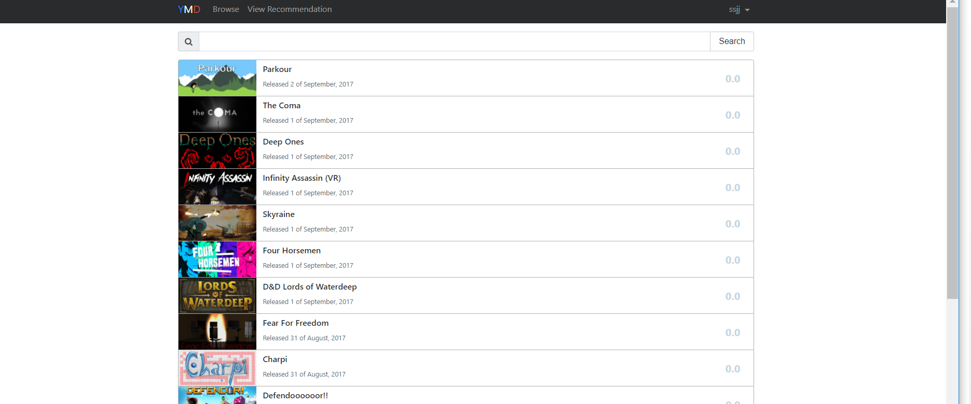





# Script 2: Browse while signed IN

## Description

* An unauthenticated user will visit a page of the site where the navigation bar is offered (currently all pages)
* Attempt to browse games while signed in
* Observe the result – Review the games listed and the ability to search and review searched results

## Setup

* The testing user should ensure they are logged in
* The testing user should ensure a user is presented with a list of games and the ability to search for games

|  |  |  |  |  |
| --- | --- | --- | --- | --- |
| **Step #** | **Test Step** | **Expected Test Results** | **P** | **F** |
| **1.** | Visit the site | Site loads with no errors |  |  |
| **2.** | Click “Sign in” in the top right | A modal window appears asking for login details. Enter Credentials |  |  |
| **3.** | Click “Browse” in the top left next to YMD which is the home button | A modal window appears with the option to be able to search games from a presented list of games |  |  |
| **4.** | Review the listed games under search bar | Games are listed |  |  |
| **5.** | Enter game name from the list in the search bar and click on Search | Page refreshes and the searched game is the only one listed |  |  |

|  |  |  |  |  |
| --- | --- | --- | --- | --- |
| **6.** | Enter a keyword not listed as game name | The page refreshes with a message of “no games found” |  |  |

|  |  |
| --- | --- |
| **Field Name** | **Data** |
| Username | sjsj |
| Password | password |
| Valid Game name entered and Searched | Wingless |
| Invalid Game name entered and searched | XYZ |

|  |  |  |  |
| --- | --- | --- | --- |
| Date/Time | Tester | Test Phase | Status |
| 24/08/17 12:30 | Shailesh Jha | Alpha | Passed |

**Please refer to the screenshots above as Script 1:**

# 

# Script 3: Browse while signed OUT

## Description

* An unauthenticated user will visit a page of the site where the navigation bar is offered (currently all pages)
* Attempt to browse games WITHOUT signing in
* Observe the result – Review the games listed and the ability to search and review searched results

## Setup

* The testing user should ensure they are NOT signed in
* The testing user should ensure a user is presented with a list of games and the ability to search for games

|  |  |  |  |  |
| --- | --- | --- | --- | --- |
| **Step #** | **Test Step** | **Expected Test Results** | **P** | **F** |
| **1.** | Visit the site | Site loads with no errors |  |  |
| **2.** | Click “Browse” in the top left next to YMD which is the home button | A modal window appears with the option to be able to search games from a presented list of games |  |  |
| **3.** | Review the listed games under search bar | Games are listed |  |  |
| **4.** | Enter game name from the list in the search bar and click on Search | Page refreshes and the searched game is the only one listed |  |  |

|  |  |  |  |  |
| --- | --- | --- | --- | --- |
| **5.** | Enter a keyword not listed as game name | The page refreshes with a message of “no games found” |  |  |

|  |  |
| --- | --- |
| **Field Name** | **Data** |
| Username | sjsj |
| Password | password |
| Valid Game name entered and Searched | Wingless |
| Invalid Game name entered and searched | XYZ |

|  |  |  |  |
| --- | --- | --- | --- |
| Date/Time | Tester | Test Phase | Status |
| 24/08/17 12:56 | Shailesh Jha | Alpha | Passed |

# Script 4: Gain Information on searched or browsed game

## Description

* An unauthenticated user will visit a page of the site where the navigation bar is offered (currently all pages)
* Attempt to browse games with and without signing in
* Observe the result – review information presented to the user upon clicking on a specific game

## Setup

* The testing user should ensure they are on the homepage and has the option to browse games
* The testing user should ensure a user is presented with information on games and ability to rate a game upon clicking on a specific game presented to the user either via searching or simply browsing signed in or NOT signed in

|  |  |  |  |  |
| --- | --- | --- | --- | --- |
| **Step #** | **Test Step** | **Expected Test Results** | **P** | **F** |
| **1.** | Visit the site | Site loads with no errors |  |  |
| **2.** | Click “Browse” in the top left next to YMD which is the home button | A modal window appears with the option to be able to search games from a presented list of games |  |  |
| **3.** | Click on a listed game under the search tab | Page refreshes with information on just the clicked game and provides a user ability to rate the game if signed in or provides the option of signing in to rate |  |  |
| **4.** | Search for a game via the search bar and click on the searched resulted game | Page refreshes and the searched game is the only one listed and a user can click on that game to gain information on that game and has the ability to rate the game if signed in or provides the option of signing in to rate |  |  |

|  |  |
| --- | --- |
| **Field Name** | **Data** |
| Username | sjsj |
| Password | password |
| Valid Game name entered, searched and reviewed | Wingless |
| Game Clicked on from the list provided under the search bar | Little Earth |

|  |  |  |  |
| --- | --- | --- | --- |
| Date/Time | Tester | Test Phase | Status |
| 24/08/17 13:06 | Shailesh Jha | Alpha | Passed |

**Please refer to the screenshots above as Script 1 and the below:**



# Script 5: Filter Games

## Description

* An unauthenticated user will visit a page of the site where the navigation bar is offered (currently all pages)
* Attempt to filter browsed or searched games upon signing in
* Observe the result – review information presented to the user upon applying different filters to refine browsed or searched result

## Setup

* The testing user should ensure they are signed in and on the homepage and has the option to browse games
* The testing user should ensure a user is presented with refined results upon selecting specific filter when browsing or searching while signed in

|  |  |  |  |  |
| --- | --- | --- | --- | --- |
| **Step #** | **Test Step** | **Expected Test Results** | **P** | **F** |
| **1.** | Visit the site | Site loads with no errors |  |  |
| **2.** | Click “Sign in” in the top right | A modal window appears asking for login details. Enter Credentials |  |  |
| **3.** | Click “Browse” in the top left next to YMD which is the home button | A modal window appears with the option to be able to search games from a presented list of games |  |  |
| **4.** | Click on drop down menu with “Release Date” being the default filter located right next to search bar and apply different filters by selecting from the drop down menu and then click search | Page refreshes with filtered results based on the selection made for filtration criteria |  |  |

|  |  |  |  |  |
| --- | --- | --- | --- | --- |
| **5.** | Click on drop down menu “Genre” and select the genre you want to filter results by and click search from the drop down menu and then click search | Page refreshes with filtered results based on the genre selection |  |  |

|  |  |
| --- | --- |
| **Field Name** | **Data** |
| Username | sjsj |
| Password | password |

|  |  |  |  |
| --- | --- | --- | --- |
| Date/Time | Tester | Test Phase | Status |
| 18/09/17 13:06 | Shailesh Jha | Alpha | Passed |

**Please refer to the screenshots below for refined results based on different filters applied:**

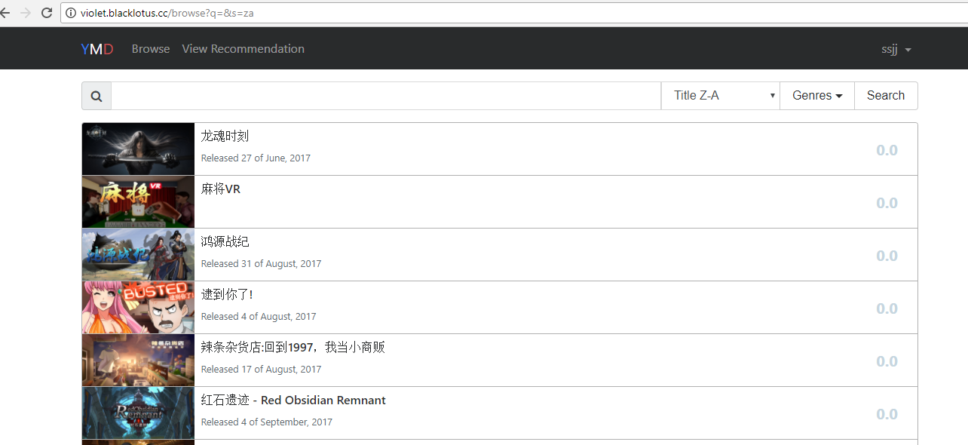

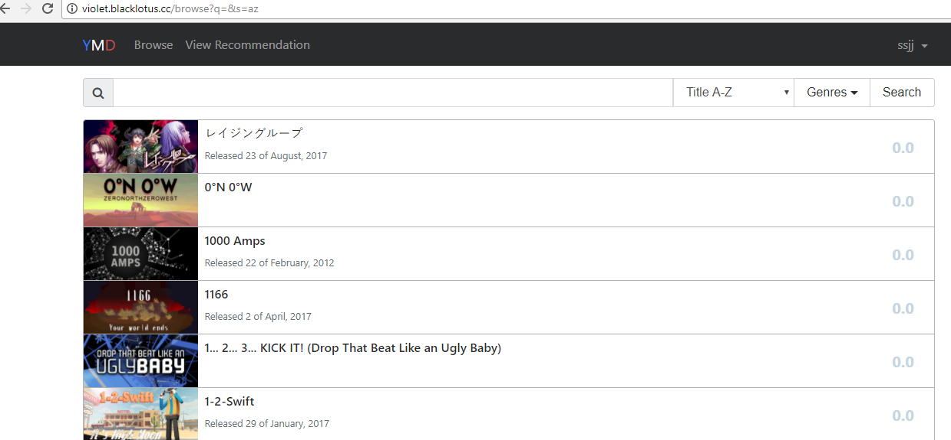

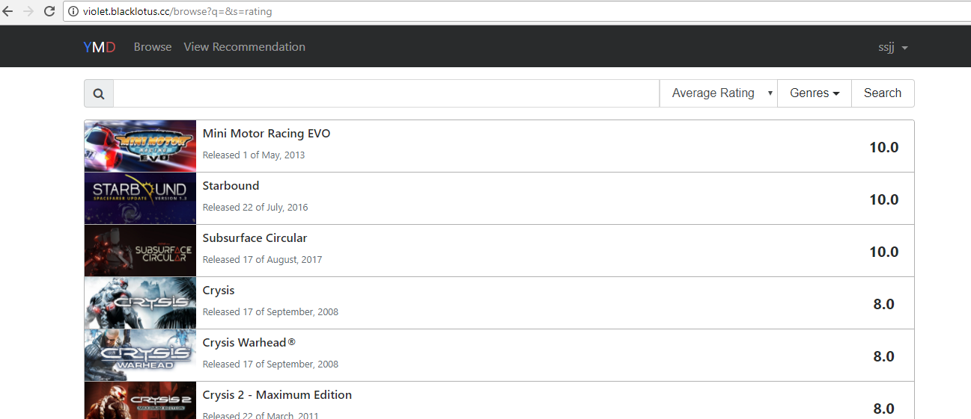

**UPON Genre Selection:**

